WHAT IS THIS URL ,, WHAT IS JTHIS REQUEST METHOD ALL CLEARD BELOW THESE ALLR ELATED TO CORS
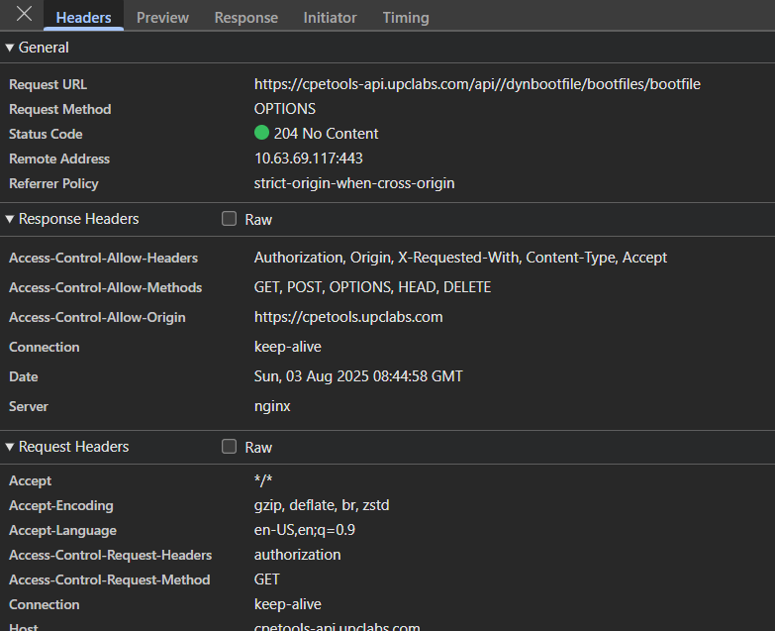
THIS is a special option conducted by the browsr to chec the compatibility and what are the sross origin methods allowed by the server

Usually the middleware used in Django handles and allows this cross origin sites

SUMMARY
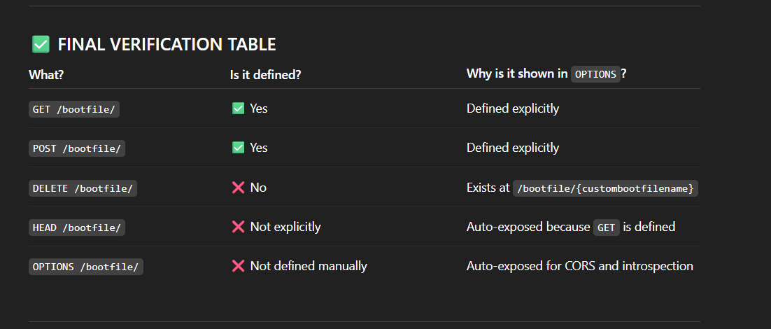
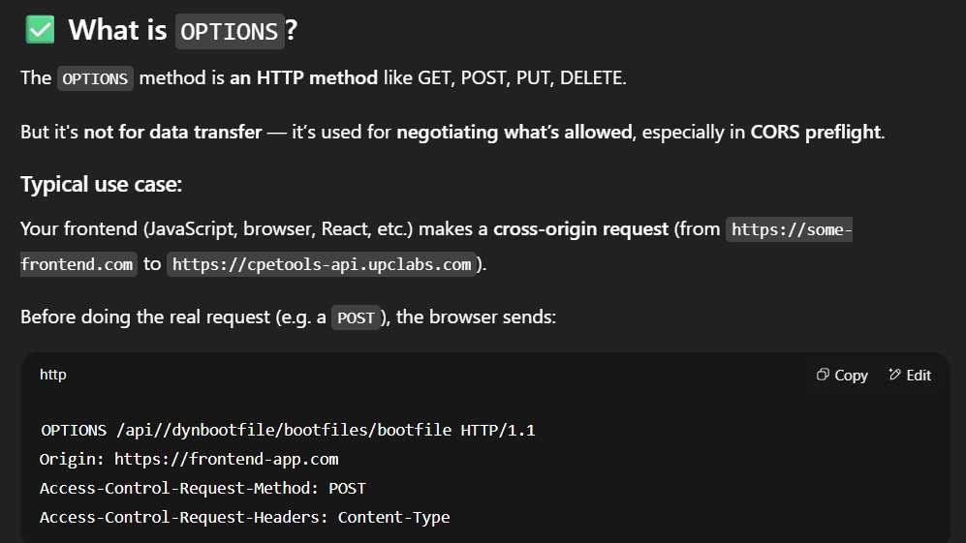
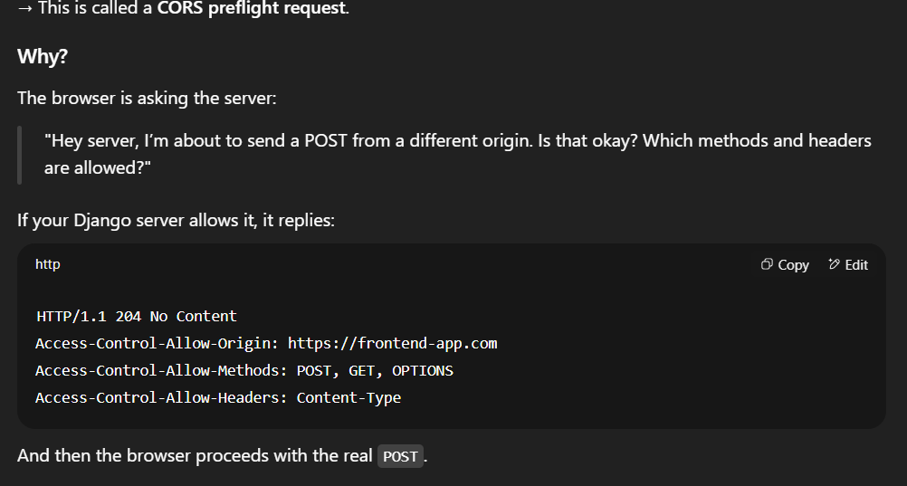
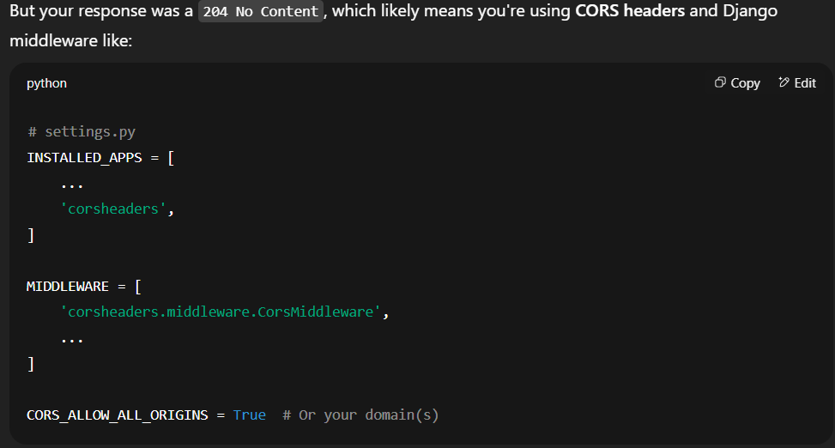
NOW HOW CORS AND THE MIDDLEWARE + DJANGO NINJA (STARLITE) HANDLES THIS
I have this in my api_controller , then how the djangoninja nd middleware know which cors to route
when I enable cors its by default enabled and the request in the base framework (like Django ninja injects all the methods like OPTIONS,HEAD ,GET,PUT,POST ,DELETE) based on the defined route like below (will come to the delete part latter how that is handled )
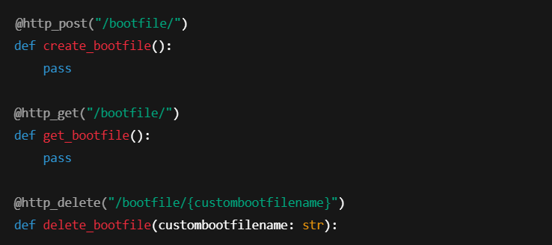
Note OPTIONS ,HEAD is by default added by the framework injected into the route objets in the backned and stored along with the methods we have defined

